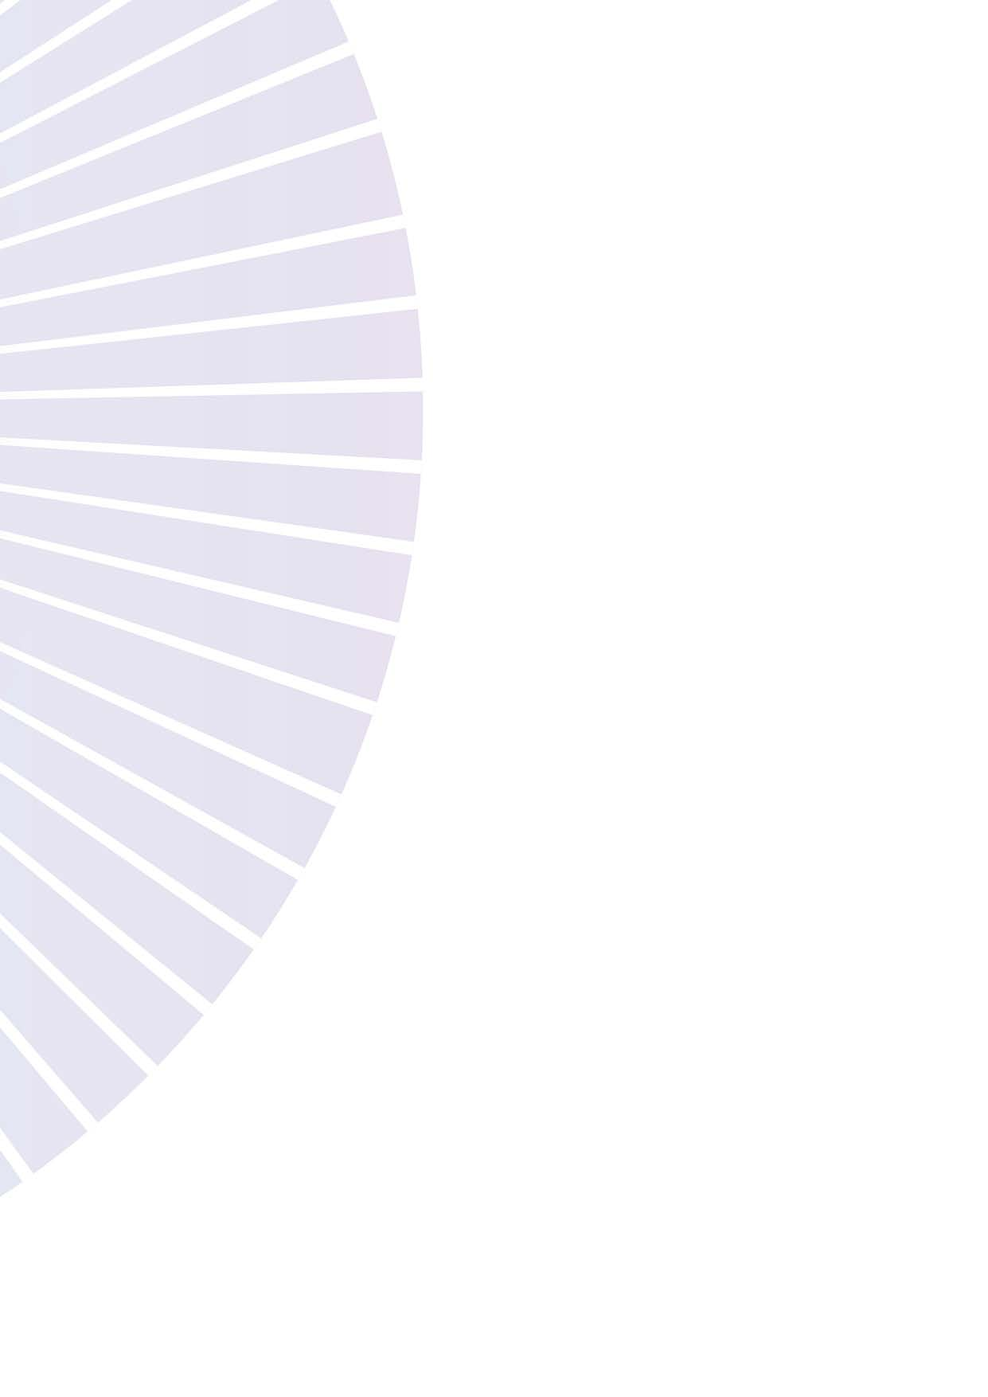

Speaking Engagement Request Form

Thank you for requesting an Equality Advocate from the Equality for All program to speak at your event. Please complete this request form and send it along with any other relevant information to belinda-Sue@whg.org.au
WHG supports equality for all and therefore we expect events for our Equality Advocates to be accessible for everyone. Accessibility may include language considerations, accessible venues, toilets, car parking, or catering requirements etc. WHG can provide further advice about specific Equality Advocate’s requirements.

If you have any further questions or concerns please contact Women’s Health Grampians on 5322 4100.
Requesting Organisation:

Key Contact Person 1:

Key Contact Person 2:
(This individual will need to be available for contact regarding the speaking engagement).

Address:

Phone:

Email:
Event Name:

Event Type & Purpose:

Event Location:

Start/End Date: Start/End Time:

Name of Requested Equality Advocate:

Proposed Speech Length:

Will there be a Q&A session?
☐ Yes ☐ No

Key messages or topics you would like to have emphasized in the speech:

Targeted Audience (e.g. healthcare professional, students etc.):

Estimated Audience Size:

- Our Equality Advocates talk about a range of topics including gender inequality and discrimination, please be aware of this in your preparation and communication with event attendees.

Presentation Set-Up : ⁪ Technology Access:
☐ Podium ☐ Projector
⁪☐ Table ☐ Microphone
☐ Stage ☐ Internet
⁪☐ Standing ☐ Computer/Laptop
⁪☐ Other (if other, please specify) ☐ PowerPoint

Will the media be contacted? Is parking available?
☐ Yes ☐ No ☐ Yes ☐ No

Type of Media:
☐ Newspaper
⁪☐ Radio
☐ TV
⁪☐ Other (if other, please specify)

Any further relevant information:

