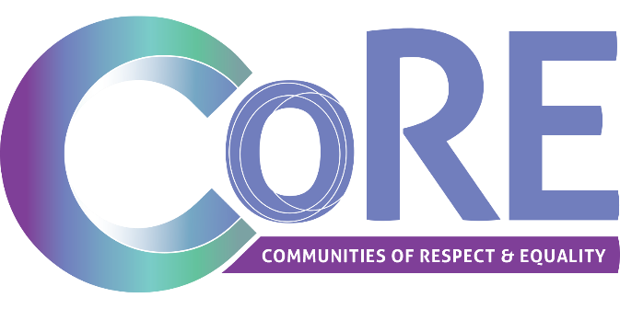

Learning from lived experience:

Mental health impacts of COVID-19 on migrant and refugee women in the Grampians region

March 2022

About this resource

In 2021 and 2022, Women’s Health Grampians undertook research into the experiences of inequalities by women from migrant and refugee backgrounds in the Grampians region during the COVID-19 pandemic, with a focus on the impacts on mental health and wellbeing.
Migrant and refugee women experience health inequality and poorer health outcomes, including mental health, compared to Australian-born women. To take action to address this health inequality, we must look at how gender inequality intersects with discrimination and racism experienced by migrant and refugee women and how this leads to a variety of health inequality impacts, including access to mental health services and supports.
Part of Women’s Health Grampians’ Health Equality for All project, this resource aims to share migrant and refugee women’s experience of the pandemic, together with actions that can be implemented by Women’s Health Grampians’ partners thought the Communities of Respect and Equality (CoRE) Alliance. Women’s Health Grampians employed two migrant women as Health Educators and Mental Health Supports and they undertook interviews with twenty local migrant and refugee women. They explored topics such as the impact of COVID-19, confidence in seeking support, experiences of accessing services and what would help make mental services more accessible for migrant and refugee women. This resource is organised into lived experience extracts from those interviews, coupled with relevant statistics and research. The research outcomes are then linked to actions and supports for CoRE members to consider.
For more information and to access further support from the Health Equality for All team at Women’s Health Grampians, please contact Kate Diamond-Keith at kate@whg.org.au.
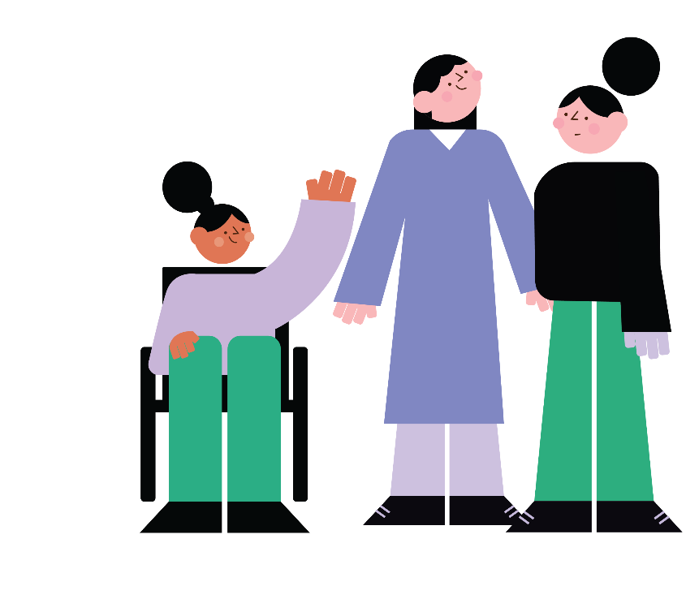

Mental health impacts of COVID-19 on women

The impacts of COVID-19 in Australia have been gendered, including in relation to mental health and wellbeing. Some of the mental health impacts of COVID-19 on women as a whole are described below.

- The COVID-19 pandemic has resulted in higher levels of anxiety and depression for women compared to men.¹
- 35% of women experienced moderate to severe levels of depression compared to 19% of men; and 27% of women experienced higher levels of stress compared to 10% of men.²
- Women’s mental health is impacted by the compounding effects of the pandemic from remote learning, childcare, isolation and mental load.³
- The pandemic may also have resulted in re-triggering or recurring mental health conditions, and strains on services are making it hard to access support.⁴
- Overrepresentation of women in casual and insecure employment means they are more likely to have lost their jobs. Unemployment is associated with declines and deterioration in mental health and self-esteem.⁵
- As a result of the pandemic, women were more likely to feel: restless or fidgety (47% of women compared with 36% of men); nervous (40% compared with 30%); that everything was an effort (30% compared with 22%); and also depressed that nothing could cheer them up (10% of women compared with 5% of men). 28% of women have experienced loneliness, compared with 16% of men.⁶
- The increasing mental health issues for women is due partly because of existing gender inequalities and pre-existing social and economic discrimination for women. Intersectionality – meaning other forms of inequality and discrimination such as racism, ageism and economic inequality – are compounding these mental health impacts for women.⁷

Mental health impacts of COVID-19 on migrant and refugee women in the Grampians region

According to the Australian Bureau of Statistics, approximately four million women – 15% of the Australian population – were born overseas.⁸ In Ballarat, 9.5% of the population were born overseas and in Horsham, 6.7% of people were born overseas.⁹
The following represents the lived experience of the twenty migrant and refugee women from the Grampians region, interviewed by Multilingual Health Educators based at Women’s Health Grampians. Corresponding research and statistics about the impact of COVID-19 on migrant and refugee women’s mental health are also included.
The findings are arranged into the following themes:
- Mental health impacts of COVID-19
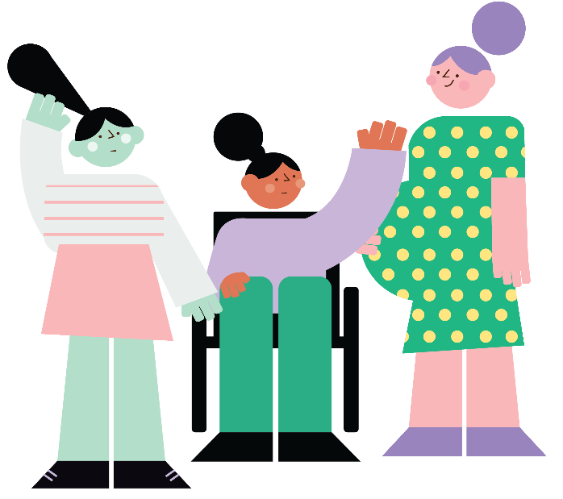
- Caring for self and seeking support
- Experiences of service access
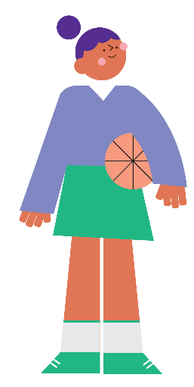

Mental health impacts
‘COVID times were very hard, especially when you are raising a young child and pregnant at the same time.’
‘COVID times was very hard I had to support other family members, where as I was feeling mentally and emotionally very tired.’
Statistics and research
- Women from non-English speaking backgrounds experience higher rates of poor mental health compared with Australian-born women.¹⁰
- The crisis had a disproportionate impact on migrant and refugee women’s mental health as it introduced new stressors and added layers of complexity to their ability to seek help.¹¹
- 90% of migrant and refugee women said that they experienced multiple hardships as a result of the COVID-19 pandemic, including mental health stress.¹²
- Migrant and refugee women reported a high connection between remote learning and the impacts of this on their mental health.¹³
- Some research has found that within migrant and refugee communities, women experience greater rates of post-traumatic stress disorder, anxiety and depression than men.¹⁴
‘COVID-19 impacted on my ability to engage with other members of community, having young children in family, was so scared to see people to protect children. However, I needed support as well.’
‘COVID-19 had a big impact on my relationship with my partner, which caused me a lot of stress. I found that I was doing more work (unpaid care duties and household) whereas partner was just working from home.’
‘COVID-19 has impact on me because everything is hard especially when I go to see the doctor, there is someone at the door asking a lot of questions and I don’t understand English.’
‘I came to Australia five years ago. COVID-19 has changed everything, for example - no English language classes so I can’t go to learn the language. No jobs around for people who don’t speak any English at all. It is very hard for me to keep things as a normal.’
‘It is scary that If I catch up the COVID-19 and bringing it to my family because I am going around by public transport.’
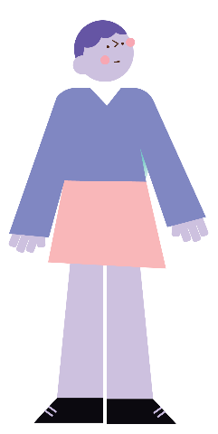
‘COVID-19 has impacted everyone because things are not going in the right direction. Too many lockdowns and hard to see the doctor, home schooling for my kids, everyone was staying home day and night during the lockdown it’s hard. Nowhere to go for visits. Everyone is losing their jobs and I nearly lost my job too because of pandemic.’

Caring for self and seeking support caring for self
‘I was so busy trying to manage my life with two children who are a year apart, so did not actually have a chance to link into support services.’
Statistics and research
Contributing factors to increased mental health stress included:
  - Lack of information about COVID-19 in language or easy English
  - Fear and worry about own health and health of loved ones in Australia and overseas
  - Loss of loved ones overseas and grief for not having been able to attend funerals and participate in cultural burial rites
  - Being cut off from families and support networks
  - Loss of jobs and family income, economic insecurity, and financial distress
  - Uncertainty about the future and feelings of helplessness
  - Increase in experiences of family and domestic violence as well as abuse and control at home
  - Increased burden of caring duties and responsibilities at home
  - Gaps in availability of critical services, especially in rural and remote areas
  - Rise in racial attacks and everyday experiences of racism, both online and in person
  - Increased presence of police due to lockdowns and border closures triggering traumatic memories for refugees and survivors of violence
  - Strict public health measures reducing social mobility and physical activity¹⁵

‘I feel during COVID times everything was moved to phone or online, which I feel was very challenging to get services. Especially when you have kids around you.’
‘I am aware of some services available for mental health, but I was not very confident to approach these services, I was not sure what issue I should deal with first. Things went upside down during COVID.’
‘I have confidence to support my wellbeing - like doing gardening when I don’t have work to do, when I come inside I put music on and I dance and sing at the same time. Some other way is I called my relatives members for chatting and I do this daily to make sure my day is going smoothly.’
‘The services I used to support my physical and mental wellbeing is knowing when I am not in good mood each day when I got up from bed, I am aware of these things because I am a nurse in Africa and here. I am supporting myself by calming my mind and not talking a lot when I am at work or home and not sitting so long in one spot. I move around or go for a walk.’
‘My way of seeking some support for my wellbeing is to tell myself that everything will be okay, I pray to God to help me to thinking right in term of my mental wellbeing.’
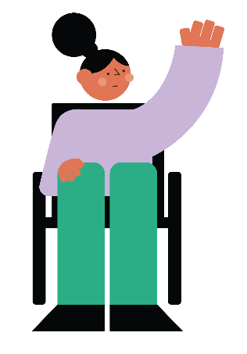
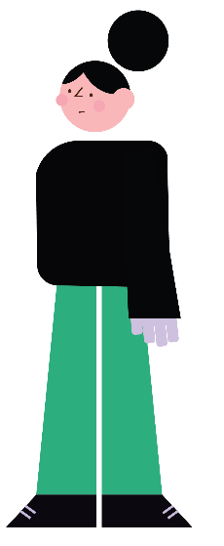
‘When I need some support for my wellbeing, I cleaned my house or called friends to make me think in a different way and how I’m interacting with my thoughts. I listen to music on my phone while I’m walking around. It is hard to describe how I felt in the past those two years has just gone.’

Accessing services
Statistics and research
- Those who provide services to migrant and refugee women reported a significant rise in reports of mental health issues experienced by women.¹⁶
- Migrant and refugee women experience additional barriers to accessing mental health services—including communal stigma—resulting in negative consequences and outcomes, they often have to overcome many barriers to accessing help, which was made even more challenging by the COVID-19 pandemic.¹⁷
- The COVID-19 pandemic has further exacerbated the pre-existing barriers for migrant and refugee women accessing health services such as:
  - Navigating online services
  - Lack of interpreting service provision available in their localities
  - Inability to access mental health services in a culturally safe way
  - Fear of being racially profiled by police when going out for health appointments during lockdowns
  - Postponing non-emergency needs such as those relating to chronic health conditions due to the pandemic
  - Increased control from partners or families at home
  - Visa conditions that locked certain cohorts of migrant and refugee women out of critical services during the pandemic¹⁸
‘I have accessed a maternal health nurse walk in and phone line for child, but not anything related to mental health.’

‘I was initially linked with the new parent’s group then COVID happened. We tried to keep it online but it was very hard. I decided to fall through this.’
‘I was referred to social worker, but online appointments were not good for me. I decided not to continue my appointments.’
‘I have accessed mental wellbeing supports, I am aware of my wellbeing and seeking help when I need it. I help young people to get away from bad mood moving forwards in their life and I try to help others to help themselves.’
‘No, I haven’t seen my social worker for long time because of COVID-19. Nobody is talking to me about my mental wellbeing support, when I need to talk to someone then I called my relatives or friends. South Sudan have a good community network here, but they have a limiting English language. We are talking in other languages.’
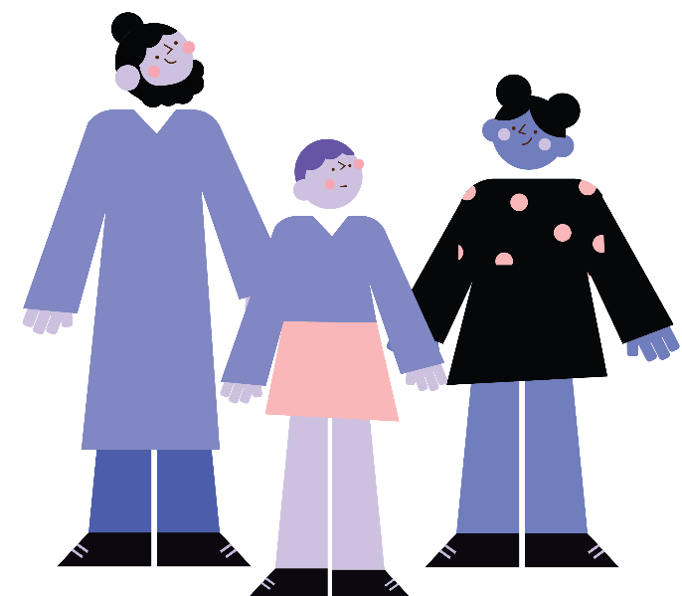
‘I felt I had nowhere I could access support for my mental wellbeing because of COVID-19. Only thing I did was to try to keep calm and acting like balancing self-energy especially during home schooling for my kids. Talking to them in a different way when I was in my home.’

Outcomes, actions and supports

Mental health and other service providers in the Grampians Regional can learn from these lived experiences of the impacts on migrant women’s mental health and accessing services and reflect on ways to ensure services are culturally safe, accessible and inclusive for migrant and refugee women in the region. These lived experience stories provide insights into the real every day experience of migrant and refugee women in the community and are a powerful tool for change and addressing barriers to accessing services.

Research outcomes

- COVID-19 had significant impacts to migrant women’s mental health resulting from lockdowns, restrictions and isolation.
- Most migrant and refugee women were caring for others, children and extended family.
- Many women did not access mental health supports and instead tried to look after their own mental wellbeing themselves or within their community.
- Many found telehealth appointments difficult especially with language barriers.
- Women from migrant and refugee backgrounds found the ‘entry’ questions to medical centres and services hard to understand, was confronting and presented barriers.
- Some migrant women knew services were available but did not have the confidence and knowledge to be able to navigate the system i.e. phone or online booking systems.
- Support services and group activities online did not support migrant and refugee women.
- Migrant and refugee women were getting most of their mental health supports from their own communities through supporting each other.
- Consistent language and cultural safety barriers resulted in women not feeling confident to access services or seek help.
- Online services did not appear to be fulfilling the needs and supports of the migrant and refugee women.

Taking action
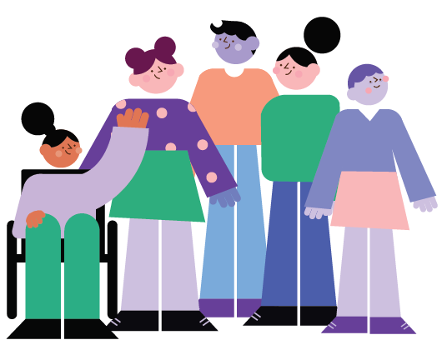
- Include cultural safety training in professional development requirements.

- Embed processes and procedures for staff to access translators and promote this regularly to staff.

- Ensure information is available in multiple languages in public places in medical centres.

- Consider employing professionals who can speak different languages to provide services to migrant and refugee communities.

- Improve communications with clients i.e. ensure migrant women have information about who the appointment is with, the location of the appointment, and provide information that lets them know the service is supportive and culturally safe. Migrant and refugee women want this to be an easier process than it is now.

- Provide accessible information about your service i.e provide clear information about the how service operates especially in regard to fees, cancelled appointments and rescheduling appointments.

- Provide flexible service options and have a variety of options available to access services – provide clients with a choice in how they want to seek support

References
1. GenVIC (2021). This Conversation is Not Over: Women’s mental health during the COVID-19 pandemic. Melbourne, Victoria. Available at: https://www.genvic.org.au/focus-areas/genderequalhealth/this-conversation-is-not-over-womens-mental-health-during-the-covid-19-pandemic/.
2. Ibid.
3. Ibid.
4. Ibid.
5. Ibid.
6. Women’s Mental Health Alliance (2020). Policy Brief: Women’s mental health in the context of COVID 19 and recommendations for action, Melbourne, Victoria. Available at: https://womenshealthvic.com.au/resources/WHV_Publications/Policy-Brief_2020.06.16_Womens-mental-health-in-the-context-of-COVID-19_(Fulltext-PDF).pdf.
7. Ibid.
8. Migration, Australia: Statistics on Australia's international migration, internal migration (interstate and intrastate), and the population by country of birth. Available at: https://www.abs.gov.au/statistics/people/population/migration-australia/latest-release
9. City of Ballarat (2022). City of Ballarat: Birthplace. Available at: https://profile.id.com.au/ballarat/birthplace.
10. GenVIC and Multicultural Centre for Women’s Health (2021). Left Behind: Migrant and Refugee Women’s Experiences of COVID-19 Report. Melbourne, Victoria. Available at: https://www.mcwh.com.au/left-behind-migrant-and-refugee-womens-experiences-of-covid-19-report/.
11. Harmony Alliance (2021). National Consultation Report: Migrant and Refugee Women in the COVID-19 pandemic – impact, resilience and the way forward. Available at: https://harmonyalliance.org.au/wp-content/uploads/2021/02/HA-Membership-Forum-Report.pdf.
12. GenVIC and Multicultural Centre for Women’s Health (2021). Left Behind: Migrant and Refugee Women’s Experiences of COVID-19 Report. Melbourne, Victoria. Available at: https://www.mcwh.com.au/left-behind-migrant-and-refugee-womens-experiences-of-covid-19-report/.
13. Ibid.
14. Sullivan, C., Vaughan, C. and Wright, J. (2020). Migrant and refugee women’s mental health in Australia: a literature review. University of Melbourne, Victoria. Available at: https://www.mcwh.com.au/wp-content/uploads/Lit-review_mental-health.pdf.
15. Harmony Alliance (2021). National Consultation Report: Migrant and Refugee Women in the COVID-19 pandemic – impact, resilience and the way forward. Available at: https://harmonyalliance.org.au/wp-content/uploads/2021/02/HA-Membership-Forum-Report.pdf.
16. Ibid.
17. Ibid.
18. Ibid.

